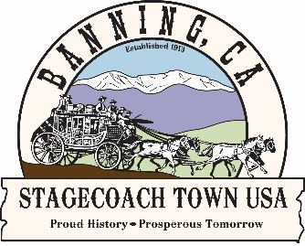

City of Banning

99 E. Ramsey Street P.O. Box 998 Banning, CA 92220-0998 • Office: 951-922-3125

COMMUNITY DEVELOPMENT
DEPARTMENT
Adopt-A-Roadway Program
Clean-Up Report

Please return this form to Banning City Hall along with photos from the clean-up for documentation within 24 hours of each clean-up event. Or email report and photos to CommunityDev@banningca.gov.

Date of Cleanup: ____ ____ Organization Name: ________________________________________
Your Adopted Roadway Number: __________ Number of Trash Bags Filled: __________
Number of Volunteers: __________ Hours Worked: __________

Intersection where trash was left: _______________________________________________________________________
EXAMPLE: At the corner of S. 3rd Street and W. Ramsey Street, NOT blocking walking path.

Please list any bulky items collected and the amount (such as; furniture, appliances, tires, etc.)*:

EXAMPLE: Shopping cart (1), Tires (5), Mattress (1)

Notes/ requests/ comments to City of Banning’s Adopt-A-Roadway Project Coordinator:

Primary Contact:

Name: ______________________________________ Phone: _________________ Email: ________________________

*Note: Items collected by Banning Roadway Adoption participants should be litter and debris that can fit into the trash bags provide. Tires, brush and other bulky items should be stacked nearby, not on top of, or under trash bags. Bags of collected trash should not exceed 20-25 pounds. Filled bags should be clustered in convenient locations for solid waste collection. Bags should not be placed in the road or on the sidewalk.

