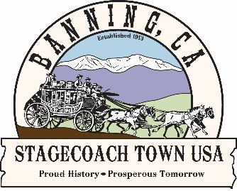Adopt-A-Roadway Program

City of Banning

99 E. Ramsey Street P.O. Box 998 Banning, CA 92220-0998 • Office: 951-922-3125

COMMUNITY DEVELOPMENT
DEPARTMENT
Instructions & Safety Requirements
- Complete the Volunteer’s Agreement to Release All Liability Form.
- For groups with children 10 years of age or younger, there must be a 3-to-1 ratio of children to adults. For groups with children between the ages of 11-18, there must be a 5-to-1 ratio of children to adults.
- No open-toed shoes, or flip flops.
- Volunteers must wear safety vests provided be the City at all times.
- Stay in open areas and use the buddy system.
- Work in small groups.
- Stay alert at all times.
- Stay away from traffic, motorists, and construction zones.
- Remember, tools are not toys.
- Do not pick up broken bottles or sharp objects – use a trash grabber.
- Do not touch anything that may be toxic or hazardous.
- Note the location of an unsafe item and report it to a team leader and the City.
- NEVER let others go off alone!
- Keep trash bags at 20lbs.
- Do not drag trash bags, pick them up.
- Double tie all trash bags.
- Bags are to be piled at major street corners or designated location.
- Be cautious of bulky items.
- Gently kick the item to make sure animals are not hiding underneath or around it.
- Place bulky items next to the trash bags.
- Flatten tumbleweeds and palm fronds and place them under trash bags.
- If an animal poses a threat or you find a dead animal DO NOT TOUCH THEM!
- Call the Dept. of Animal Services: 951-358-7387.
- If you have health issues (such as respiratory problems, or diabetes), notify your team leader before the start of the project.
- Bring any necessary medication with you.
- Do not overwork yourself.
- Stay hydrated.
- In the event of a medical emergency, dial 9-1-1.

